Project title: The Tragedy of Flight:A Comprehensive crash analysis

1.Introduction:

1.1 Overview

An airplane crash analysis is a detailed investigation into the causes of an aviation accident. The goal of an airplane crash analysis is to identify any factors that contributed to the accident, with the ultimate goal of improving safety and preventing future accidents. The process of conducting an airplane crash analysis typically involves the collection and analysis of a wide range of data, including information about the aircraft and its systems, the operators, and any other relevant factors. This data is typically collected from Kaggle. Once the data has been collected, it is analysed through tableau, to identify any potential causes of the accident. The results of an airplane crash analysis are typically published in a report, which may include recommendations for improving safety and preventing similar accidents in the future. These recommendations may be implemented by the relevant authorities or industry organizations.

1.2 Purpose

This project is used to analyse the aviation industry, human error is the major cause of accidents. About 38% of 329 major airline crashes, 74% of 1627 commuter/air taxi crashes, and 85% of 27935 general aviation crashes were related to pilot error.[3] The Swiss cheese model is an accident causation model which analyzes the accident more from the human factor aspect. In the modern aviation industry, it is also used to analyze a database of past accidents in order to prevent an accident from happening. Many models have been used not only for the accident investigation but also for educational purpose.

2.Problem Definition and Design Thinking

2.1 Empathy Map

2.2 Ideation and Brainstorming map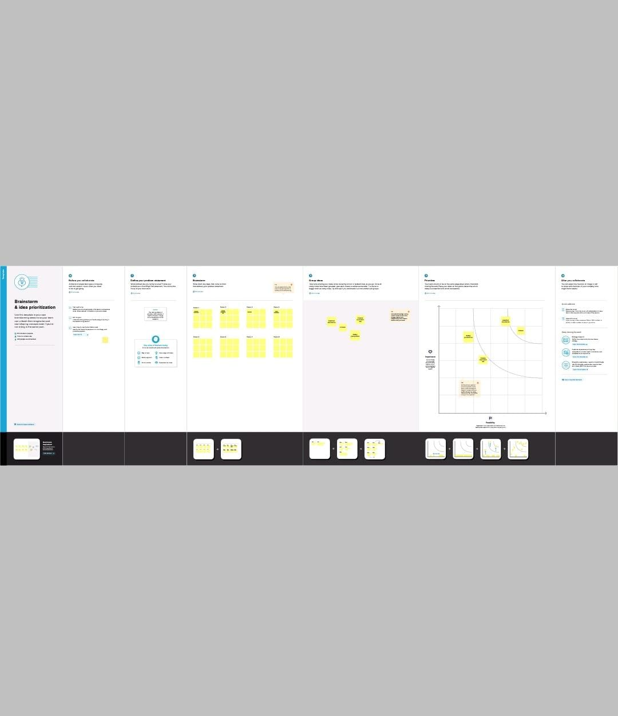

3.Result

To effectively discover the hazards that led to the accident and to prevent their recurrence in a future accident or incident. In the course of that investigation, additional hazards which increased damage and injury. Organizational influences: This layer is about resources management, organizational climate and organizational process. For example, a crew underestimating the cost of maintenance will leave the airplane and equipment in bad condition.This layer includes inadequate supervision, inappropriate operations, failure to correct a problem and supervisory violation. For example, if emergency procedure training is not provided to a new employee, it will increase the potential risk of a fatal accident.

The objective of accident analysis is to prevent accidents in the future. This statement is not as trivial as it looks: to many the objective is to identify those who were responsible, or simply to fulfill a legal or organisational requirement. When incidents are investigated, the emphasis should be concentrated on finding the root cause of the incident so you can prevent the event from happening again. The purpose is to find facts that can lead to corrective actions, not to find fault.

4.Advantages and Disadvantages

* To effectively discover the hazards that led to the accident and to prevent their recurrence in a future accident or incident. In the course of that investigation, additional hazards which increased damage and injury (inadequate crashworthy systems, system safeguards, rescue team response, etc.)
* Emissions from aviation are a significant contributor to climate change. Airplanes burn fossil fuel which not only releases CO2 emissions but also has strong warming non-CO2 effects due to nitrogen oxides, vapour trails and cloud formation triggered by the altitude at which aircraft operate.

5.Applications

* Aviation accident analysis is an important part of aviation safety research. We used long-term sequence aviation accident statistics to analyze the characteristics of historical aviation accidents and predict the future direction of aviation accidents.
* In the physical effects, air crash brings about death, disability and injuries. The effects from air crash are determined by among other things, the cause of the crash, the altitude and its speed at the time of crash.

6.Conclusion

* This project is performed to determine the cause of errors once an accident has happened. In the modern aviation industry, it is also used to analyze a database of past accidents in order to prevent an accident from happening. Many models have been used not only for the accident investigation but also for educational purpose
* The year and the fatalities of airplane crash analysis is given below.

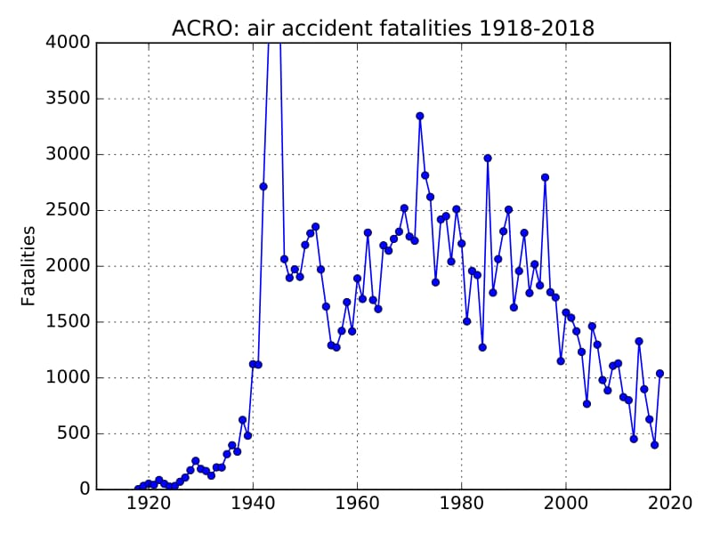

7.Future scope

* Aviation accident analysis is an important part of aviation safety research. We used long-term sequence aviation accident statistics to analyze the characteristics of historical aviation accidents and predict the future direction of aviation accidents.
* Major airlines experienced no onboard fatalities and had a fatal accident rate of 0.0 per 100,000 flight hours in 2021. This contrasts sharply with general aviation, which experienced 341 on board fatalities and had a fatal accident rate of 0.951 per 100,000 flight hours.

8.Appendix

* The number of airplane accidents have been decreased year by year,it is shown below.

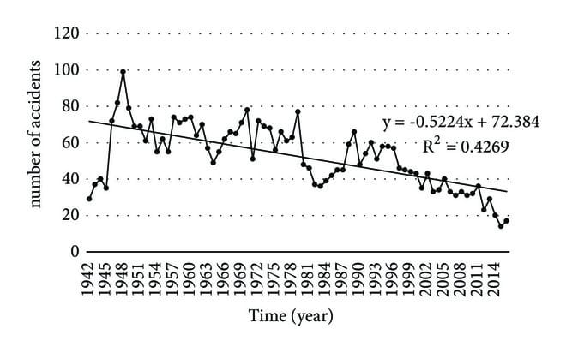

* The number of deads,foreign passengers and people survived in the early 21st century is shown in the graph below.

